Path
# Source: AI Source: Provided by: [Data Path: Persons Table -> ID Column: 1, Name_En Column: Motasem Essam] -> From: [Chatgpt (GPT‑5 Mini)] on [1/26/2026]
In computing, a path is the location or address of a file or folder on a computer. It tells the operating system exactly where to find a specific file or folder in the storage hierarchy.
Think of it like a map or directions: it shows the route from the “root” of your storage to the item you want.

Types of Paths
# Source: AI Source: Provided by: [Data Path: Persons Table -> ID Column: 1, Name_En Column: Motasem Essam] -> From: [Chatgpt (GPT‑5 Mini)] on [1/26/2026]
a) Absolute Path – Full address from the root of the system.
- Example (Windows):
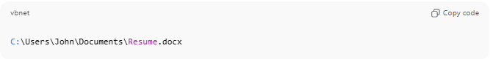
C:\Users\John\Documents\Resume.docx
- Example (Mac/Linux):
/home/john/Documents/Resume.docx
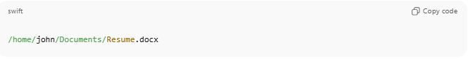
- Explanation: Starts from the main root (C: in Windows or / in Linux/Mac) and specifies every folder until the file.
b) Relative Path – Address relative to the current folder you are in.
- Example: If you are in C:\Users\John\Documents\, then the file Resume.docx can be accessed with:
Resume.docx
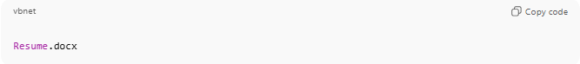
- Or if in Documents and the file is in a subfolder Projects:
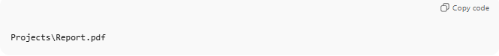
Projects\Report.pdf
- Explanation: Doesn’t start from the root; it’s shorter and depends on your current location.

Components of a Path
# Source: AI Source: Provided by: [Data Path: Persons Table -> ID Column: 1, Name_En Column: Motasem Essam] -> From: [Chatgpt (GPT‑5 Mini)] on [1/26/2026]
- Drive/Root: Starting point (C: in Windows, / in Linux/Mac).
- Folders: Intermediate directories (Users, John, Documents).
- File name: The actual file (Resume.docx).
- Extension: Indicates file type (.docx means a Word document).

Why Paths Are Important
# Source: AI Source: Provided by: [Data Path: Persons Table -> ID Column: 1, Name_En Column: Motasem Essam] -> From: [Chatgpt (GPT‑5 Mini)] on [1/26/2026]
- They tell the computer where to find a file.
- They are used in programming, command-line operations, and file management.
- Without a path, the system wouldn’t know which file you want.

💡 Analogy:
# Source: AI Source: Provided by: [Data Path: Persons Table -> ID Column: 1, Name_En Column: Motasem Essam] -> From: [Chatgpt (GPT‑5 Mini)] on [1/26/2026]
- File = A house
- Folder = The street/block where the house is
- Path = The full address (Street, City, Country)

